**Trial balance App UI:**

* Initial screen

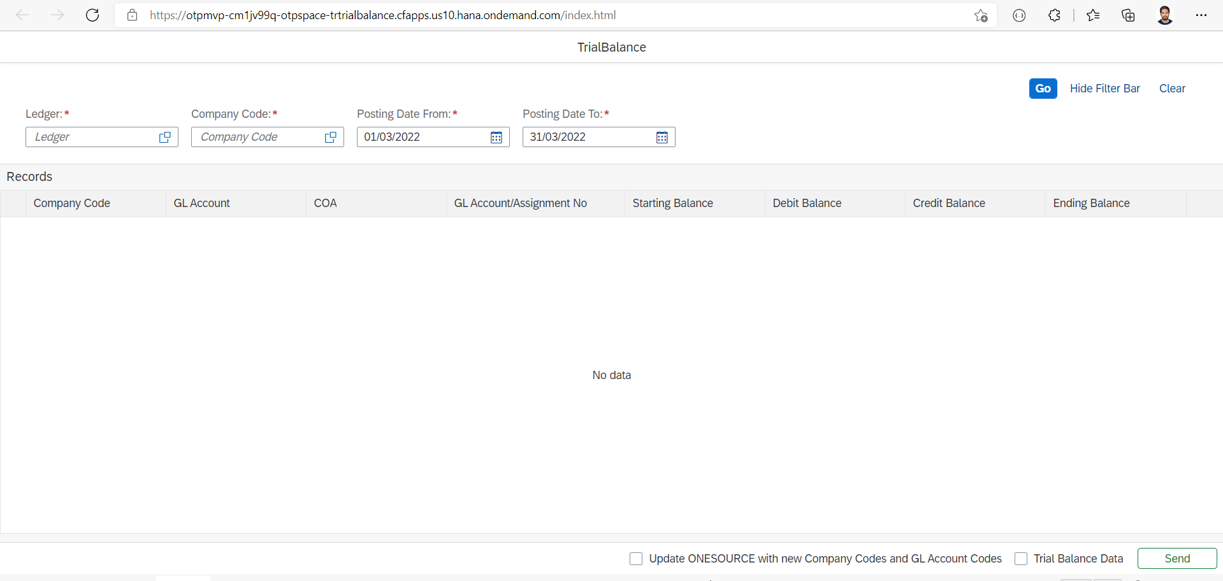

**Service calls for Selection fields and Post data to OTP:**

* /srv/getLedger – to get ledger data from s/4 Hana
* /srv/getCompanyCode – to get company code data from s/4 Hana
* /srv/getTrialBalanceData – to get trial balance data from s/4 Hana
* /srv/PostTrialBalanceData – to post trial balance data to OTP
* /srv/PostCOAMasterData – to post master data to OTP

**Validations:**

* Ledger, Company code, From Date and To date are mandatory fields to get Trial balance data.

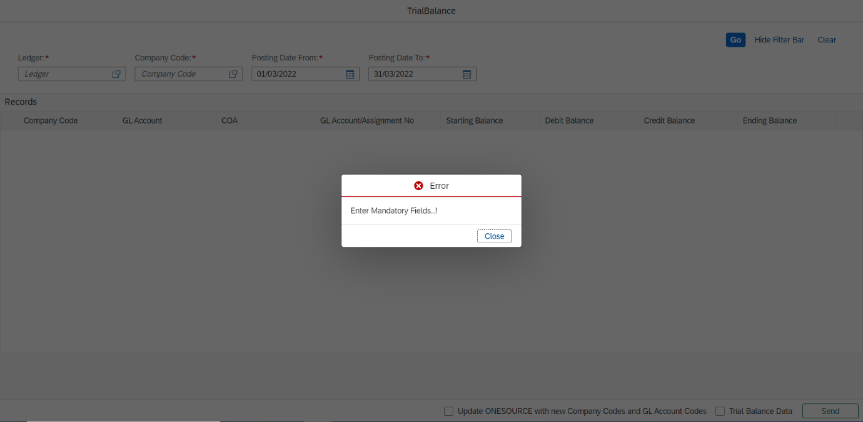

* Time Period Validation.
* From date should be less than To date.

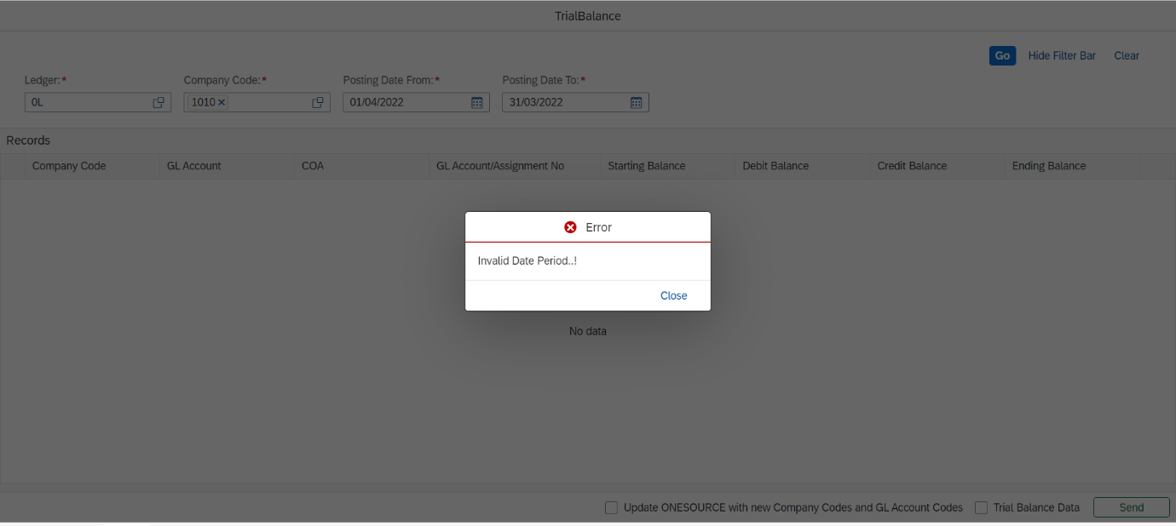

* Check box validation for service calls(Trial balance or Master data)
* At least one check box need be selected to post data.

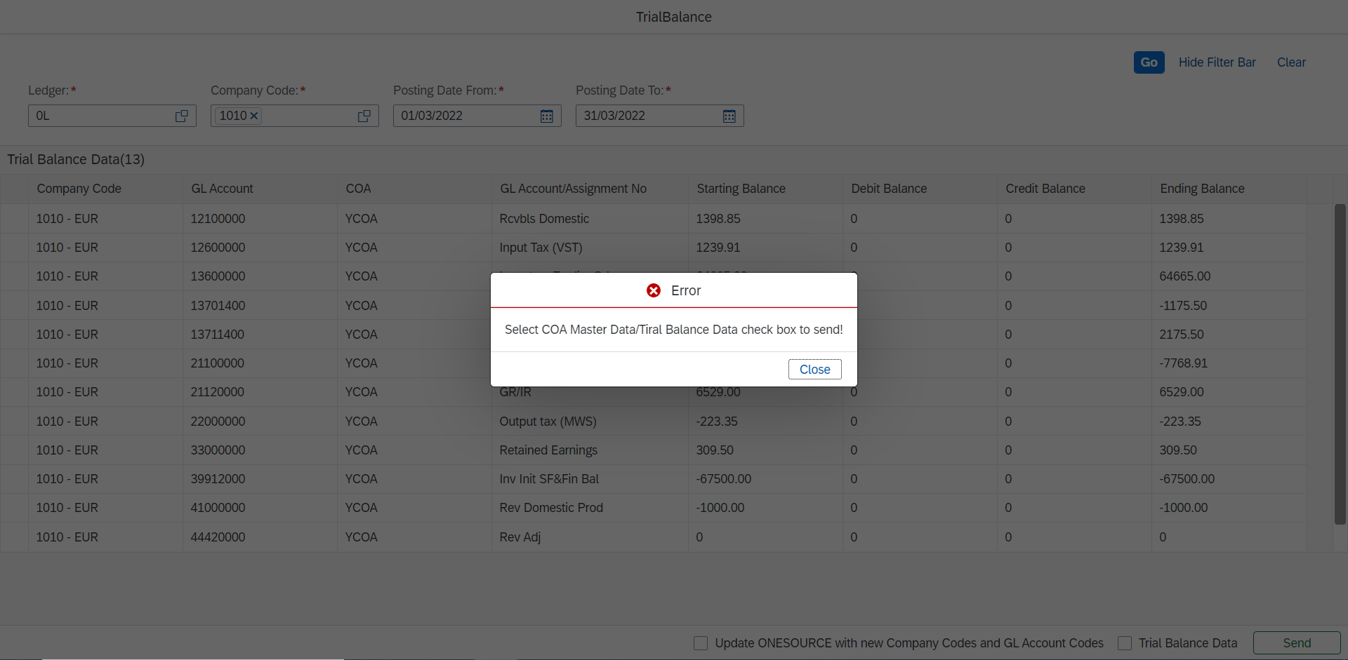

**Error handling:**

* 404 Not Found

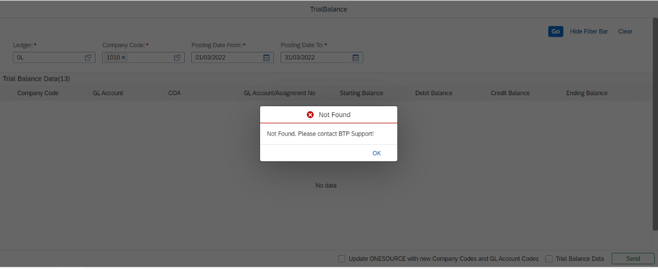

* 400 Bad requests

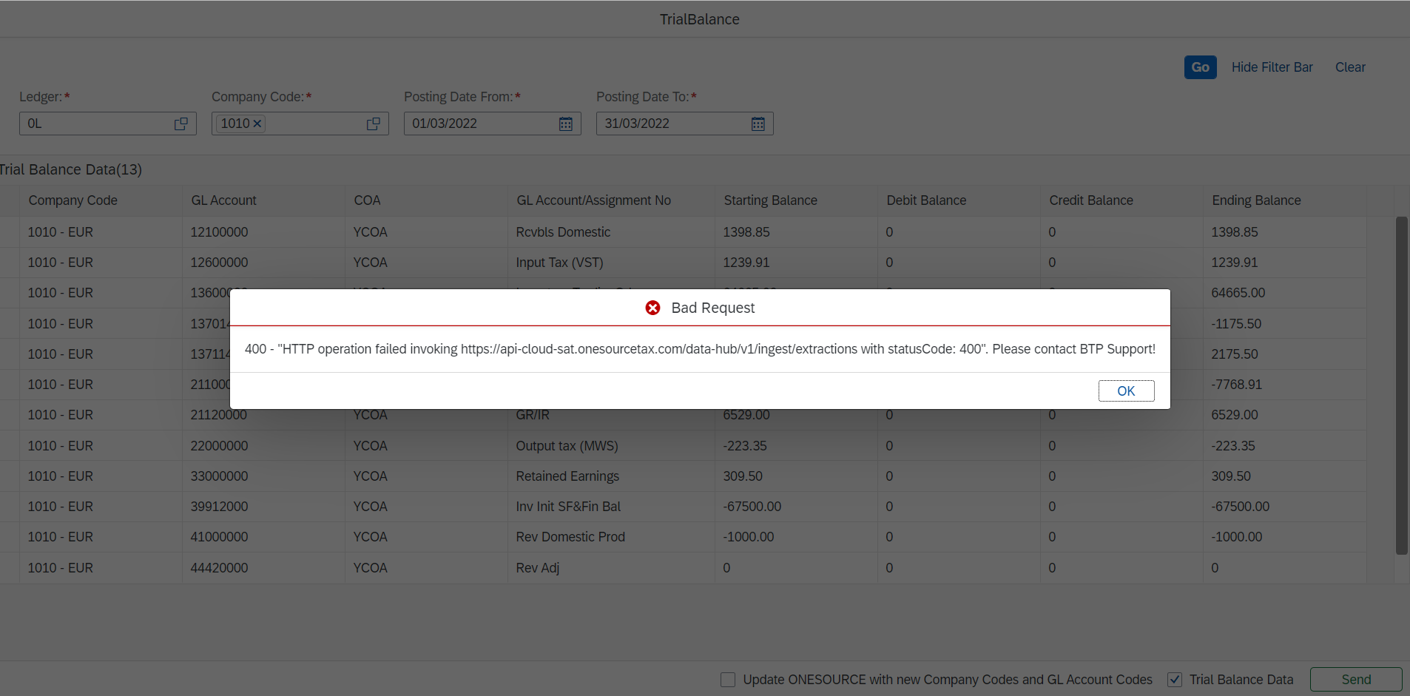

**Authorization Check:**

* Tenants need to have subaccount access

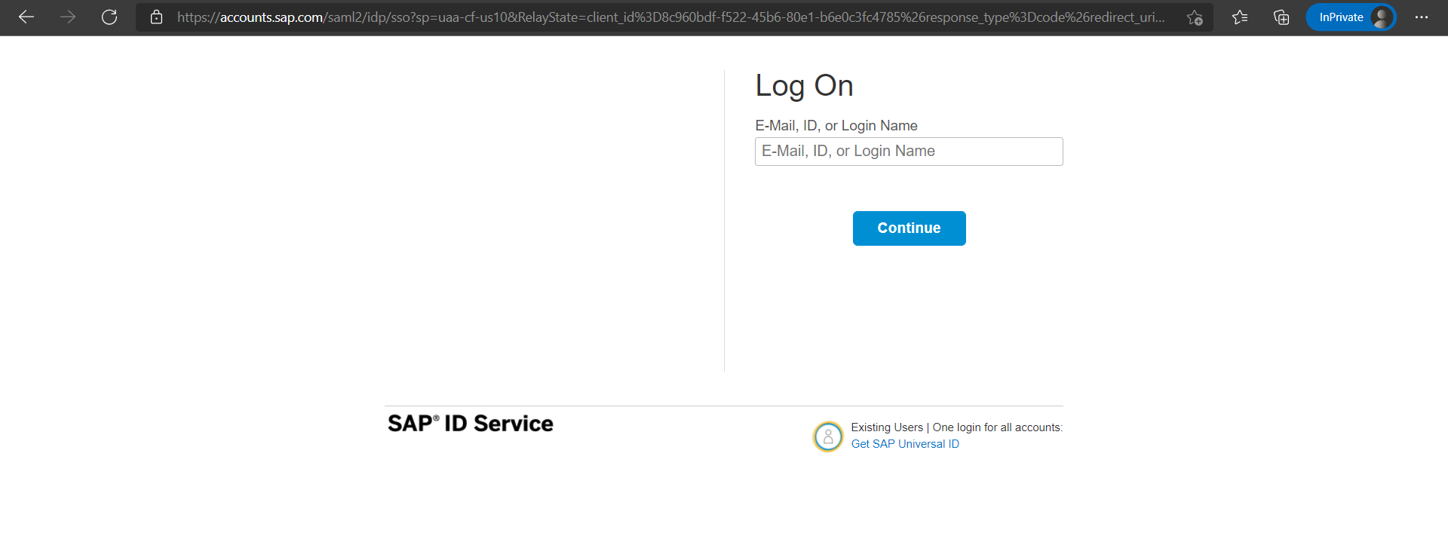

* Tenants need to have a role to get/post data

